Gripper project research
In the realm of robotics and automation, the quest for optimal gripper design stands as a cornerstone in enabling machines to interact dynamically with the world around them. This report will focus on the diverse designs and solutions for grippers.
This comprehensive research spans an array of researched gripper types, going in-depth on their design choices and unraveling the positives, negatives, and limitations of each one of them. In addition to investigating various gripper designs and solutions, this research will delve into the development of a unique solution for our 'Agrobot', which faces its distinct set of limitations.
Beyond hardware, this study additionally extends into software solutions. It will present the coding solutions and intricacies that synchronize with the grippers’ functionality, exploring how programming influences the efficacy of gripping actions.

Research
The research phase serves as an in-depth exploration into the landscape of gripper designs and solutions. Through investigation and comparative analysis, this section will look into various gripper types – their strengths and weaknesses, limitations, and applicability in diverse scenarios.

Purpose of the gripper
The primary objective of the gripper within our agricultural robot, an AI-driven system orchestrated on the Robot Operating System (ROS) using Python, is to facilitate the autonomous harvesting of simulated plastic crops. Our robot operates within an environment designed to mimic real agricultural settings, with the intention of harvesting plastic replicas of real crops - lettuce, carrot, radish, and beetroot.
The gripper serves a pivotal purpose, enabling the robot to execute precise and adaptable grasping of crops. The gripper needs to easily maneuver and securely grip crops of different shapes and sizes, replicating the dexterity required in handling real crops.

Crops
When designing a gripper suitable for harvesting a variety of crops – lettuce, carrot, radish, and beetroot – there is a distinctive difference between each plant. The main problem lies in the need of a universal gripper capable of effectively harvesting all these crops despite their contrasting physical differences.
Lettuce specifically really stands out among the crops due to its fragile nature and variability in shape and leaf structure. The leaves require a gripper design wide enough to securely hold onto the lettuce without causing damage to the crop. Contrariwise, the carrot, radish, and beetroot share more robust and compact structures, they vary significantly in shape and size. The critical design challenge lies in engineering a gripper that strikes a balance between delicacy and strength.

Existing solutions in Gripper Design for Robotic Harvesting
Exploring the current landscape of different gripper solutions reveals a spectrum of innovative solutions. Real world examples help illustrate the different challenges posed by harvesting various crops:

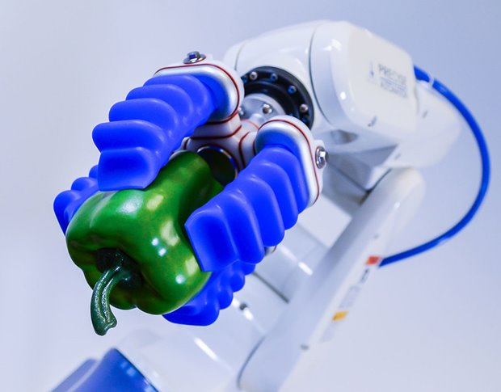
Soft Robotic Grippers
Soft gripping solutions showcase adaptability and delicate handling. The soft grippers excel in conforming to diverse shapes and sizes, offering gentle handling which is crucial for fragile crops such as lettuce.

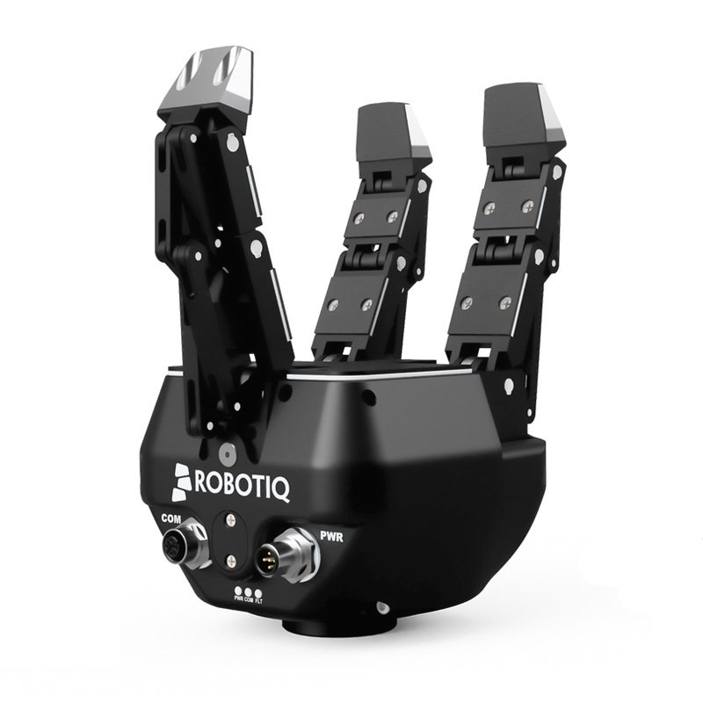
Force-sensing Grippers
Force-sensing grippers specialize in integrating real-time force-feedback mechanisms to optimize grip strength dynamically. These grippers detect force variations, ensuring a secure hold and can work autonomously on gripping a large variety of items without causing any damage.

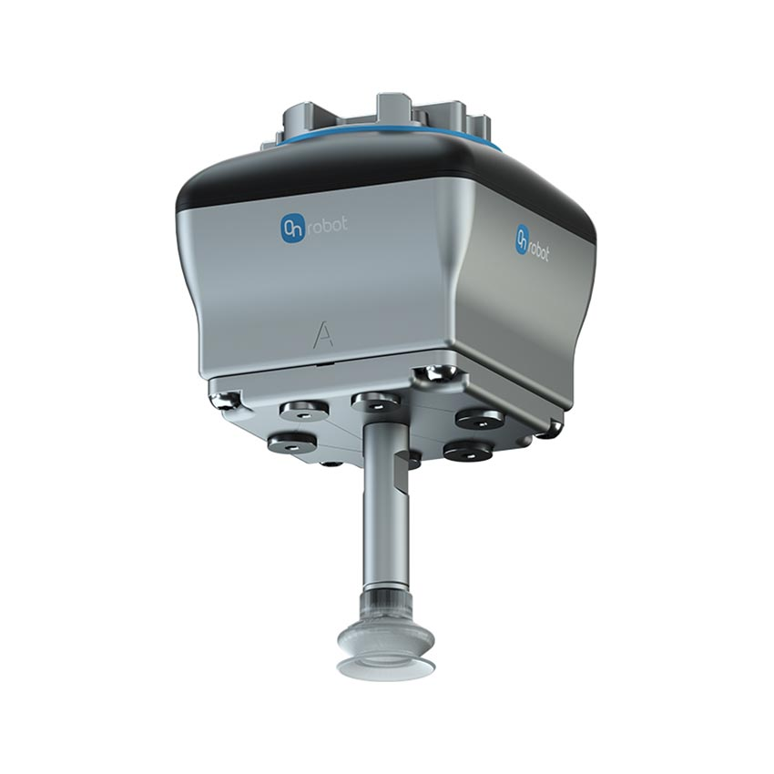
Vacuum-Based Grippers
Vacuum-based grippers can employ a network of suction cups strategically positioned within the gripper to create a vacuum seal upon contact with the crop service. It is important to note that vacuum-based grippers only work on crops without many leaves, but the vacuums can be integrated into hand grippers on the palm or at the fingertips to increase grip strength.

Design
The journey towards the current gripper design starts with a thorough assessment of various options, considering their respective advantages and disadvantages. We researched several different gripping mechanisms. Each option is categorized based on its applicability to our project’s unique requirements of harvesting fake plastic crops efficiently and cost-effectively.

Comparison of Gripper Design Options:
- Soft Robotic Grippers:
Considered for their adaptability and delicate handling. However, the high cost and potential complexity of integration to our robot system made it unfeasible within our budget and time constraints.
- Force-sensing Grippers:
Acknowledged for their precise grip adjustments. The unnecessary delicacy for our plastic crops, limited availability and potentially high cost made it an unlikely candidate.
- Vacuum-based Grippers:
Considered for their damage-free handling but were really case-specific and often costly. Gripping the lettuce would also be quite a challenge using vacuums, otherwise it would have been a good and effective solution.
The final design for the gripper must represent simplicity, affordability and give us the bare minimum functionality needed to harvest sturdy plastic crops. In addition, the gripper choice needs to integrate a camera-based movement controlled within the ROS framework. Complex grippers will also require more work on our software – a large time constraint which we could not afford.

Solution
This chapter will focus on the final solution for the gripper hardware and software.
3.1 Hardware
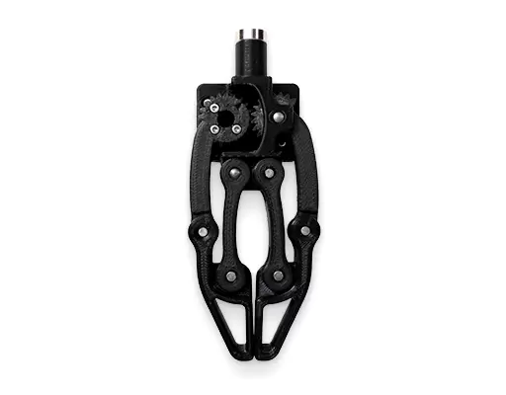
In the pursuit of our final hardware solution for the gripper, we strategically chose a 2-finger gripper, acknowledging the constraints of time, budget, and the team's expertise. With limited time scope and resources, we decided to purchase the gripper from online sources. This approach mitigated the risks associated with in-house design complexities and aligns with our project goals.
Our decision guaranteed that we have enough time to focus our attention on the functionality of the robot, ensuring that the gripper’s performance aligns with the project objectives.

3.2 Software
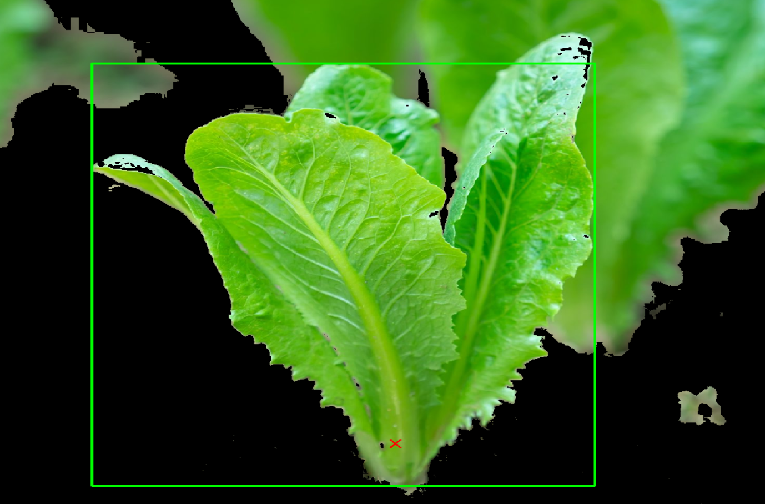
In order to find the optimal position for gripping I have implemented a color image segmentation model. This model is capable of detecting the leaves and stems of the crop right in front of the gripper and removes everything else from the background. A dedicated algorithm takes the bounding box returned from the model and processes it to locate the location of the stem, returned as X and Y coordinates from the camera vision. These coordinates are passed through a gripper movement node which takes care of converting this data into a movement trajectory for the arm and gripper of the robot. This node takes the coordinates of the stem and calculates the distance between the current location of the gripper and the stem. The distance is then converted into a value for the motors that will execute the movement trajectory. At the end, the stem should be located at the same location as the gripping point of the gripper and if that is true then the gripping movement can be started.

